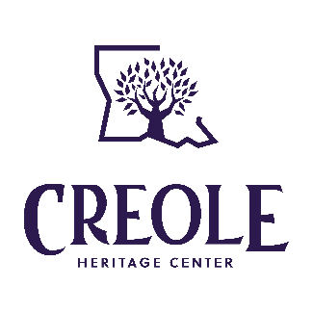
Our Vision
To revitalize, mobilize, and empower, for global recognition, Creole people and their contributions.
Our Mission
To preserve, educate, and advocate the value and significance of the vibrant Louisiana Creole people and their culture.

2026 Business/Organization Sponsorship

_____ Bronze $150
_____ Silver $250
_____ Gold $500
_____ Other Amount $_______

Total Amount Enclosed: $___________
[ ____ I wish for my gift to remain anonymous.]

Business/Organization Name: __________________________________________________________
Contact Name(s): ___________________________________________________________
Mailing Address: ______________________________________________________________
City: ________________________________________ State: ____________ Zip: _________
Phone: ___________________ E-mail: ________________________________

Mail Form and Payment to:
Creole Heritage Center at Northwestern State University
118 Kyser Hall
Natchitoches, LA 71497

Make CHECK or MONEY ORDER payable to: NSU Foundation
with “Creole Heritage Center” in Memo line

Sponsorships can also be made via credit & debit card at https://www.northwesternstatealumni.com/creole.
Just choose “Other Amount” and include a note in the comment box it is for a sponsorship and the business/organization’s contact information.

Your donation helps support our priorities for 2026:
- Develop educational materials on Louisiana Creoles for K-12 educators and students of all ages
- Construct digital and physical exhibits of verified information on Louisiana Creole people & communities
- Enhance accessibility to our Resource Library’s printed, visual, and recorded items on Creole people & heritage
- Support Creole family & Cultural Heritage events throughout the nation

All donations are processed through NSU Foundation, Inc. for the sole use of the Creole Heritage Center. Gifts made to NSU Foundation, Inc. are tax deductible to the extent permitted by law. NSU Foundation, Inc. is exempt from tax under section 501(c)(3) of the Internal Revenue Code. Its Federal Identification Number is 72-6021495.

2026 Business/Organization Sponsorship Benefits

Bronze
- Logo included on Creole Heritage Center website (www.nsula.edu/creole)
- Logo included in each eNewsletter sent monthly to over 2,800 subscribers
- Yearly recognition post on the Center’s Facebook and Instagram pages that reach almost 3,000 followers

Silver
- Logo included on Creole Heritage Center website (www.nsula.edu/creole)
- Logo included in each eNewsletter sent monthly to over 2,800 subscribers
- Quarterly recognition post on the Center’s Facebook and Instagram pages that reach almost 3,000 followers
- Featured article in one eNewsletter

Gold
- Logo included on Creole Heritage Center website (www.nsula.edu/creole)
- Logo included in each eNewsletter sent monthly to over 2,800 subscribers
- Monthly recognition post on the Center’s Facebook and Instagram pages that reach almost 3,000 followers
- Featured article in one eNewsletter
- Signage with logo at Center’s display when Center is part of community events (5 events already scheduled for 2026)

Potential Additional Opportunities for Gold level and above
- Name/Logo included in new Center publications;
- Name/Logo included on new Education & Exhibit (online & physical) materials;
- Branded item included in mailing to Center members; and/or
- Branded give-away item for Center’s table at community events

