Webex Basics for Students
Cisco Webex is a free online platform used to support virtual training sessions, workshops, and live class meetings. Faculty use Webex to conduct real-time sessions with online students, helping create an engaging and interactive learning environment.
Northwestern State University maintains a dedicated Webex site specifically for university-sponsored courses, workshops, and meetings.
System Requirements
To participate in a Webex session, please ensure you have:
- The Webex browser plugin installed and enabled (if prompted)
- A webcam (recommended)
- Working speakers or headphones
- A functioning microphone (built-in or external)
- Pop-up blockers disabled for nsula.webex.com

Joining a Webex Meeting
If your instructor provides a meeting link:
Simply click the link at the scheduled time and follow the on-screen instructions to join.
If your instructor is using their Webex Personal Room:
Navigate to:
nsula.webex.com/meet/username
Replace “username” with your instructor’s NSU username (the portion of their email address before the “@” symbol).
Example:
If Vic Demon’s email address is demonv@nsula.edu, his Personal Room link would be:
nsula.webex.com/meet/demonv
Once on the Personal Room page, click the “Join Meeting” button located in the lower-right corner of the meeting window.
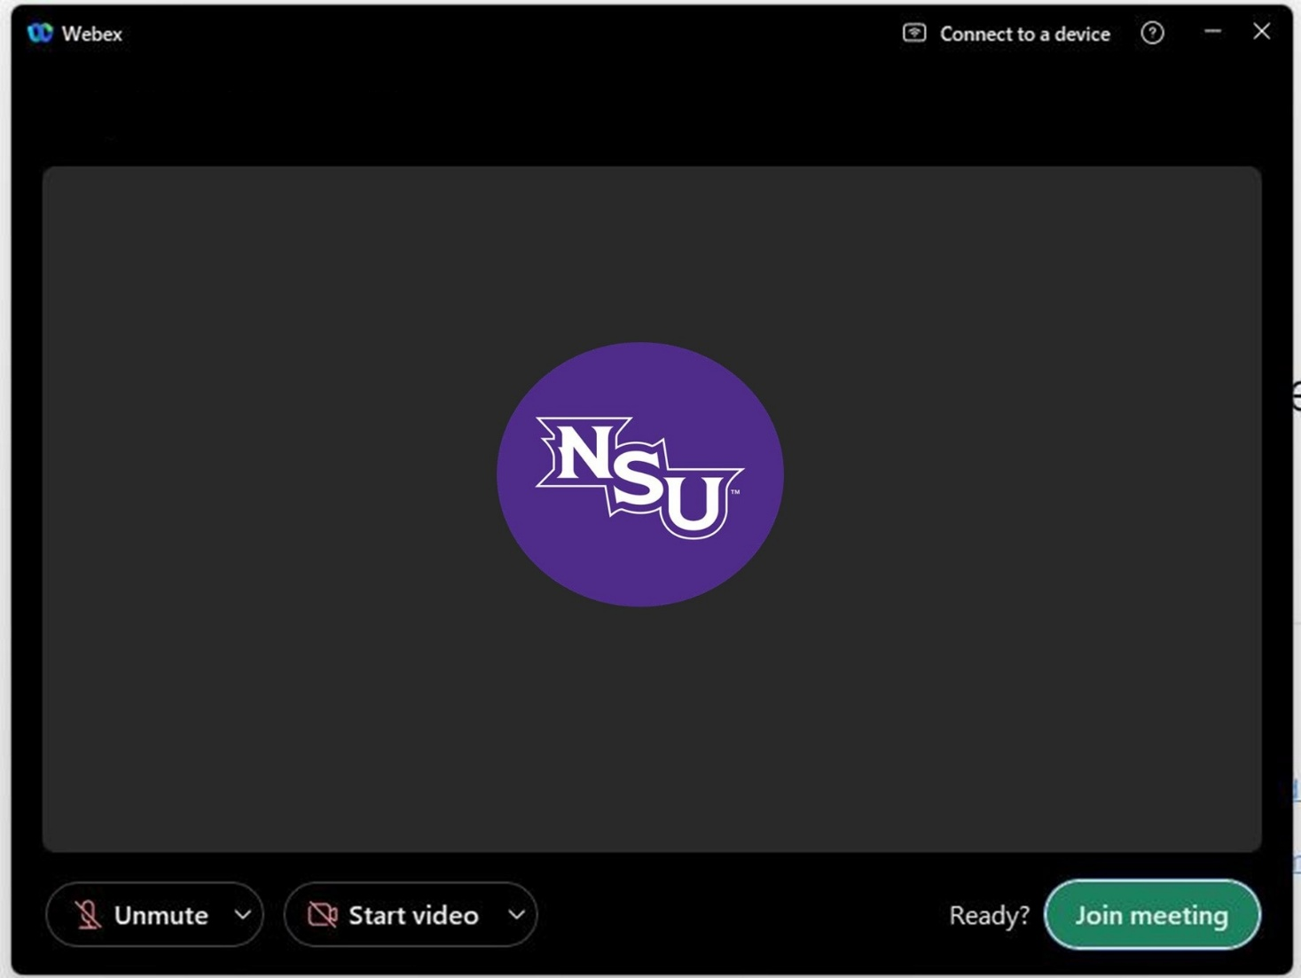

Webex Controls and Features Guide
1 2 3 4 5 6 7 8 9 10 11 12
- Toggle Closed Captioning on/off 7. Raise Hand/Reactions
- Mute or Unmute local audio device 8. Meeting Options
- Start or Stop local video device 9. Leave Meeting/End Call
- Share Content 10. Share Apps
- AI Assistance Panel 11. Participants List
- Initiate Recording 12. Meeting Chat

Sharing Content
Within your Webex Personal Room, you have several options for sharing content during a meeting:
- Screen – Share everything currently displayed on your monitor. This option allows participants to view all on-screen activity.
- Application – Share a specific open application. All currently open programs will appear in the selection menu. If you need to share a program that is not visible, scroll to the bottom and select “Other Applications.”
- File – Share an individual file directly. Participants will see a static view of the file; however, you will not be able to actively edit or interact within the application (such as Microsoft Word or PowerPoint) while using this method.
- Whiteboard – Open a blank whiteboard space where you can use annotation tools to write notes, highlight information, or collaborate visually with participants.
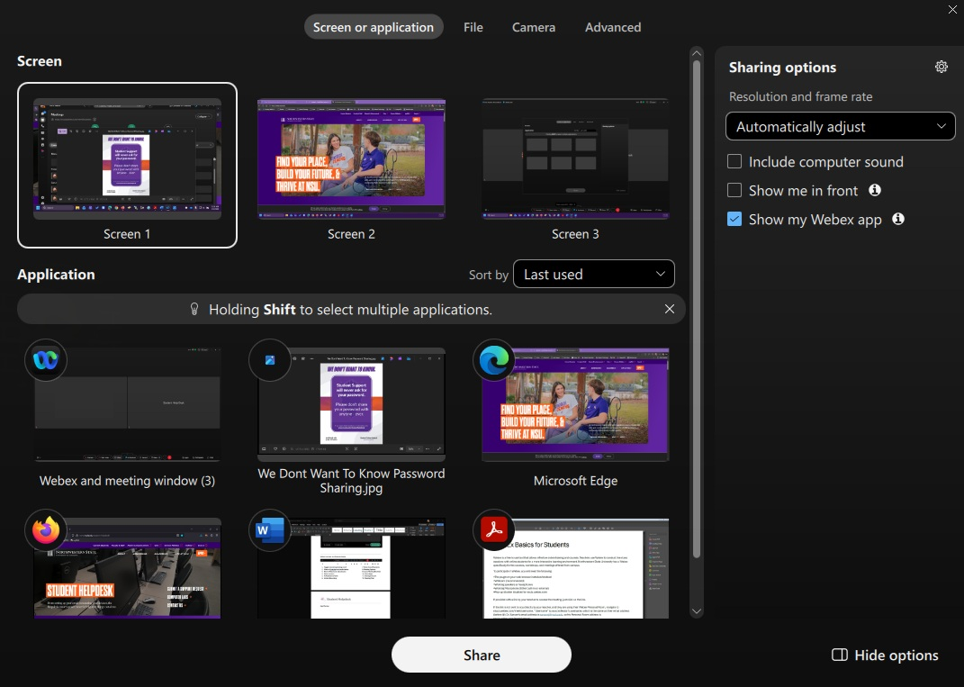

Joining a Webex Meeting from a Mobile Device
To join a meeting from your smartphone or tablet, download the Cisco Webex app from your device’s app store. Once installed, open the app and select “Join Meeting.”
When prompted, enter the meeting URL provided by your instructor, along with your name and email address, and follow the on-screen instructions to connect.
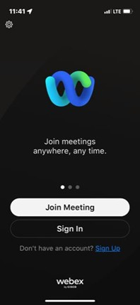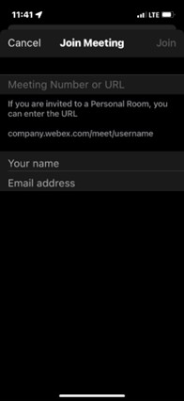
If you experience any issues, be sure to verify the meeting link and your internet connection before contacting your instructor or the Help Desk for assistance.

Please note that you may see a message that states, “You can join the meeting after the host lets you in.” on either login method. This simply means the host has not yet started the session or has not admitted participants. Once the host begins the meeting, you will be allowed to enter automatically.

